Unit 3 Research Paper: Introduction and Citations
Reading passage 3.1 Introduction Section

The introduction provides the foundation for an academic research paper. It presents the research topic, explains its significance, and guides readers toward the purpose of the study. In engineering and science, this section helps readers understand why the research is necessary, what problem is being addressed, and how the study contributes to existing knowledge or advances technology.

An introduction typically moves from general background to the specific focus of the study. This organization is often called a “funnel” structure. First, the writer introduces the research area and explains its importance. Next, the writer reviews relevant previous studies to establish what is already known. The introduction then identifies a research gap, such as an unanswered question, a limitation of previous studies, or an unresolved problem. This explains why further research is needed. Toward the end, the writer states the purpose or aim of the study and explains its contribution to the field. Research questions, hypotheses, or a brief outline of the paper may also be included, depending on the study. Although the exact organization varies, a clear introduction connects the background and research gap to the study’s purpose and contribution to the field.
Examples of purpose statements:
- This study aims to investigate…
e.g., “This study aims to investigate how surface texture affects friction.”
(本研究は，表面の質感が摩擦にどのような影響を与えるかを調べることを目的とする.)
- The purpose of this study is to develop…
e.g., “The purpose of this study is to develop a low-cost sensor for monitoring water quality.”
(本研究の目的は，水質を監視するための低コストのセンサーを開発することである.)
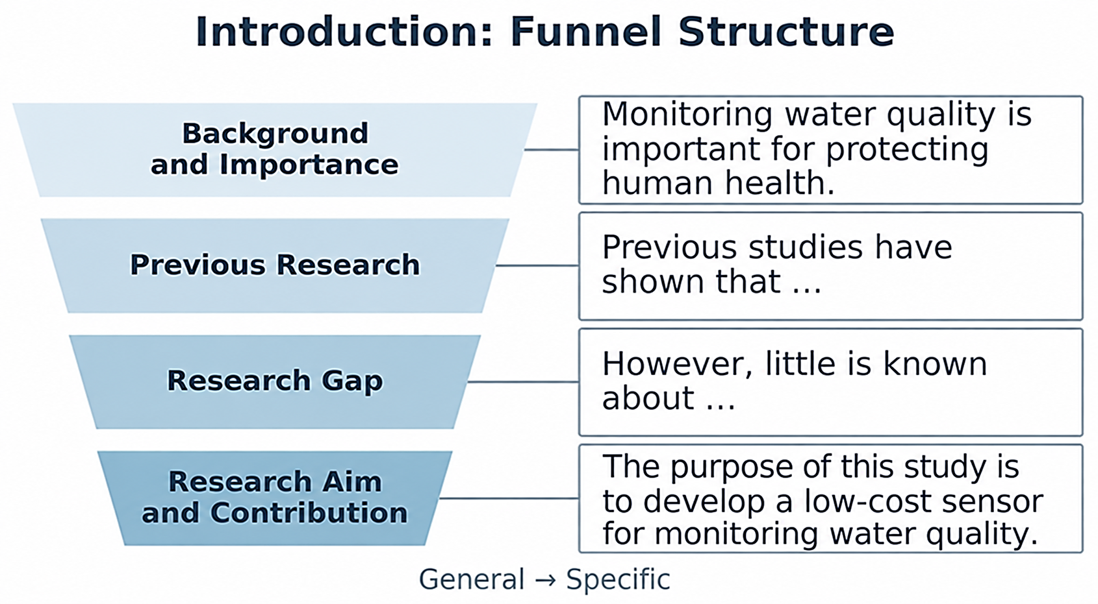

Introduction (funnel: 漏斗)
Body Part
of the Paper

A. Comprehension Questions (Homework to be submitted via the LMS)

B. Identifying the Research Gap
Look at the Introduction section of the IEEE paper. Which sentences in paragraphs 5 and 7 most clearly state a research gap? Underline the relevant sentences. Then briefly describe each problem in Japanese in the ( ) below.
--------------------------------------------------------------------------
Title：A Natural User Interface for Realistic Tactile Perception of Object Surface Texture
「(仮想空間で) 物体表面の質感をリアルに感じるための自然な操作装置」
第1段落【背景】：仮想環境における触覚(haptic)フィードバックの有用性とその種類
第2段落【先行研究①)】：モーターを動かして，力，振動，皮膚の伸びなどを与える装置
第3段落【先行研究②】：空気圧や磁場によって，材料の硬さや形状を伝える装置
第4段落【先行研究③】：画面に触れた際に摩擦刺激を与える装置
第５段落【残った問題①】：( ) という問題の指摘．➡段落のTopic sentence
第6段落【先行研究④】：振動や重さを伝える装着型触覚装置は，既に開発されている．
第７段落【残った問題②】：（ ）という問題の指摘．➡段落のTopic sentence

Reading passage 3.2 Topic Sentence and Supporting Sentences

An academic paragraph usually begins with a topic sentence, which states the main idea of the paragraph. Supporting sentences follow the topic sentence and develop the main idea by providing explanations, examples, data, or in-text citations. Together, these sentences help readers understand the writer’s ideas clearly and logically.
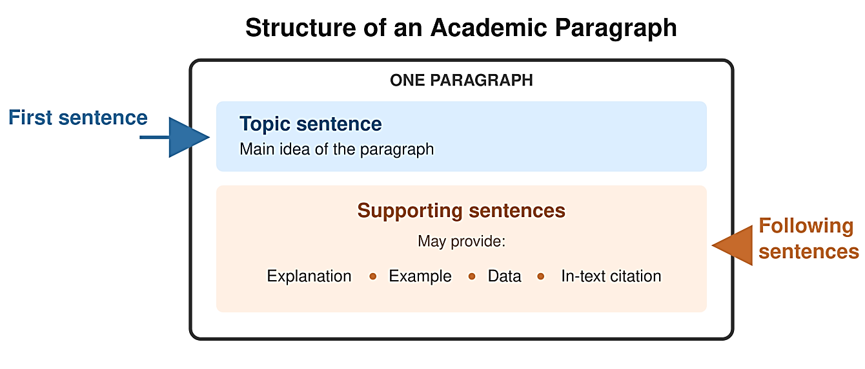
Reading passage 3.3 In-text citations (文中引用) in the Introduction Section

In-text citations are essential in the introduction of an academic research paper because they connect the study to existing research. They provide evidence to support background information and key claims. By citing relevant studies, writers can show what is already known and what remains unresolved, thereby identifying a research gap and justifying the purpose of their studies.
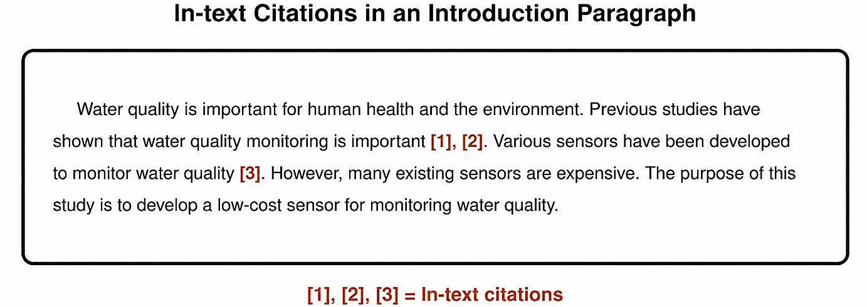
References
[1] J. Smith, “…water quality monitoring,” Journal of XX, vol. XX, no. X, pp. XX–XX, 20XX.
[2] A. Lee, “…water monitoring sensors,” in Proc. XX Conference, pp. XX–XX, 20XX.
[3] M. Brown, “…sensor accuracy,” Technical Report XX, 20XX.
Exercise: Understanding the Structure of Introduction Paragraphs

A)
Title: Improving Energy Storage and Power Grid Stability in Renewable Energy Systems
1. Introduction
(1) These studies have led to important improvements in photovoltaic cells and wind turbine design [1], [2].
(2) However, despite these benefits, problems remain in storing energy and connecting it to the power grid, limiting the wider use of renewable energy.
(3) To address these problems, this study aims to examine new ways to improve energy storage and the stability of the power grid.
(4) As a result of these improvements, renewable energy technologies have become more efficient and less expensive.
(5) The growing need for clean and sustainable energy has led to many studies on renewable energy, especially solar and wind power.

- Refer to the figure in Reading Passage 3.1 and arrange sentences (1)–(5) in the correct order to form a logical introduction.
( )

- Match each sentence with its role. Some roles may be used more than once.
- Background:
- Previous research:
- Research gap:
- Purpose of the study:
3. Which sentence contains in-text citations? What information do the citations support? (解答は日本語でもOK)

B)

Title: Machine Learning for Detecting Defective Parts with Limited Training Images
1. Introduction
(1) However, training these models requires a large number of images labeled as normal or defective, and images of defective parts are difficult to collect because defects are rare.
(2) To prevent such problems, trained workers have traditionally inspected parts visually, but this process requires time and its results may depend on the worker’s experience.
(3) To address this problem, this study aims to develop a method that can accurately detect defective parts using a limited number of training images.
(4) Defective machine parts can cause product failures, production delays, and additional costs.
(5) To improve this inspection process, recent studies have trained machine-learning models using images of normal and defective parts to detect defects automatically [1], [2].

- Refer to the figure in Reading Passage 3.1 and arrange sentences (1)–(5) in the correct order to form a logical introduction.
( )

- Match each sentence with its role. Some roles may be used more than once.
- Background:
- Previous research:
- Research gap:
- Purpose of the study:
3. Which sentence contains in-text citations? What information do the citations support? (解答は日本語でもOK)

English Grammar Focus (Self-study)
Read the following examples and note the underlined errors and their corrections.

- Subject-verb Agreement
- ×Previous studies shows that this method is effective.
→ 〇 show
- ×There has been many challenges in this field.
→ 〇 have
- Countable and Uncountable Nouns
- ×Many researches have not been conducted on this topic.
→ 〇 Not much research has been conducted…
* researchは不可算名詞なので，not much researchとし，動詞にはhasを用いる．または，Not many studies have been conducted on this topic. としてもよい.
- ×Several method are proposed in previous studies.
→ 〇 Several methods
*methodは可算名詞であり，severalの後では複数形にする．
C. Articles
- ×This paper proposes method to improve accuracy.
→ 〇 a method
* methodは可算名詞であり，ここでは単数なので冠詞が必要である．
- ×The smartphone has become a essential tool in daily life.
→ 〇 an

Grammar Exercise (Homework to be submitted via the LMS)

